**Biological background**

Methylation, chemically, is the transfer of a methyl group (-CH3) to an organic compound. This methyl groups can be transferred through addition and substitution reactions where the methyl group takes the place of a hydrogen atom on the compound.

In the field of biology, DNA methylation is an epigenetic mechanism where there is an addition of a methyl group to a cytosine residue, often to the fifth carbon atom of a cytosine ring, causing cytosine to become 5-methylcytosine and used by cells in order to control gene expression or activity. This conversion of cytosine bases to 5-methylcytosine is catalyzed by DNA methyltransferases.

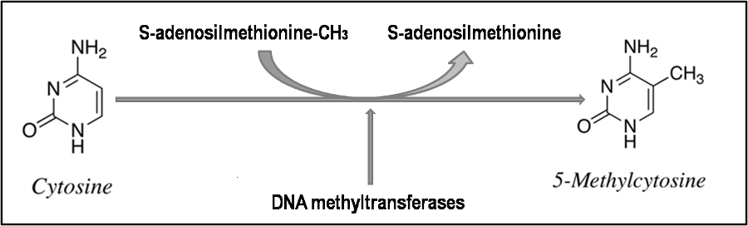

DNA methylation occurs at CpG sites—that is, sites where a cytosine lie next to a guanine base and the result is two-methylated cytosine’s positioned diagonally to each other on opposite strands of DNA.

Tumors begin with abnormal localized hypermethylation, genome-wide hypomethylation, and increased expression of DNA methyltransferase. Research shows that genome-wide hypomethylation leads to increased mutation rates and instability of chromosomes.

Bacteria use methylation as a tool for self-defense. Bacterial cells protect their DNA through the methylation of adenine or cytosine bases. Foreign DNA that enters the bacteria remains unmethylated and therefore is prone to destruction by the bacteria’s restriction enzymes.

DNA methylation is an epigenetic event that is involved in embryonic development and cell cycle regulation; hence analyzing DNA methylation of any cell provides valuable information about its cellular state, its developmental potential, and its overall health.

CpG islands defined as stretches of DNA 500–1500 bp long with a CG: GC ratio of more than 0.6 compared to the rest of the genome. Methylation is sparse but global in mammals, CpG sequences accounts for about 1–2% across the genome, aside from certain stretches (of around one kilobase) where the content of CpG is high – those are CpG islands.

CpG islands typically reside at the 5' ends of genes, and the majority of all human genes have CpG islands at their 5' end. However, CpG islands also can be found in close proximity to transcription start sites and can induce gene expression by preventing the binding of insulators that repress gene expression, suggesting there is an established recognition system. When CpG islands become aberrantly hypermethylated, it is generally associated with decreased expression of the gene by preventing the binding of factors to the DNA that promotes transcriptional activity.

While overall methylation levels and completeness of methylation of particular promoters are similar in individual humans, there are significant differences in overall and specific methylation levels between different tissue types and between normal cells and cancer cells from the same tissue. Proteins that bind to methylated DNA also form complexes with the proteins involved in deacetylation of histones. Therefore, when DNA is methylated, nearby histones are deacetylated, resulting in compounded inhibitory effects on transcription. Likewise, demethylated DNA does not attract deacetylating enzymes to the histones, allowing them to remain acetylated and more mobile, thus promoting transcription.

Given the critical role of DNA methylation in gene expression and cell differentiation, it seems obvious that errors in methylation could give rise to a number of devastating consequences, including various diseases. A large amount of research on DNA methylation and disease has focused on cancer and tumor suppressor genes. Tumor suppressor genes often silenced in cancer cells due to hypermethylation. In contrast, the genomes of cancer cells have been shown to be hypomethylated overall when compared to normal cells, with the exception of hypermethylation events at genes involved in cell cycle regulation, tumor cell invasion, DNA repair, and others events in which silencing propagates metastasis. In fact, in certain cancers hypermethylation is detectable early and might serve as a biomarker for the disease.